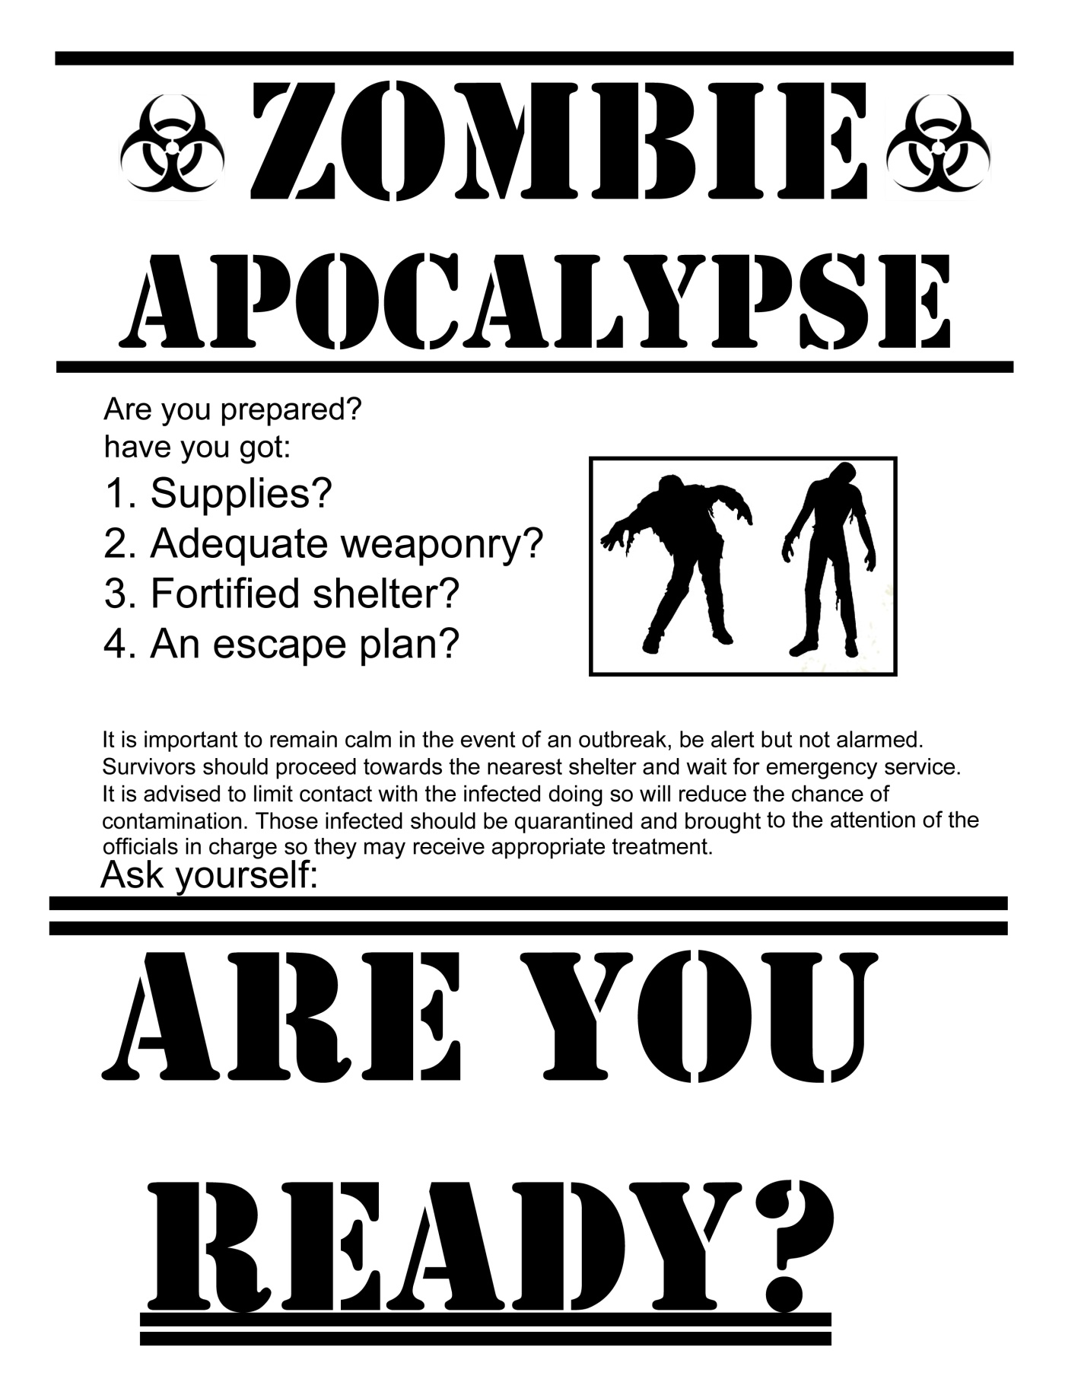

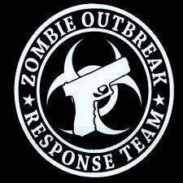

25 February 2020

To Whom it May Concern:

The Zombie Outbreak Response Team is currently looking for members. Due to the most current outbreak and loss of current members, the ZORT is looking for qualified applicants from the ages of
16-20.
Those interested must compose an e-mail to zort@zombieapocolypse.com outlining the following:
- Why are you interested in being on the team?
- What skills do you have?
- What are you past experiences with zombie hunting? Survival?
- How would you be an asset to our team?
- How can we reach you?
Thank you for your consideration and willingness to fight for our lives!

Sincerely,

Carrie L. Wisehart
Head Survivalist, Zombie Outbreak Response Team

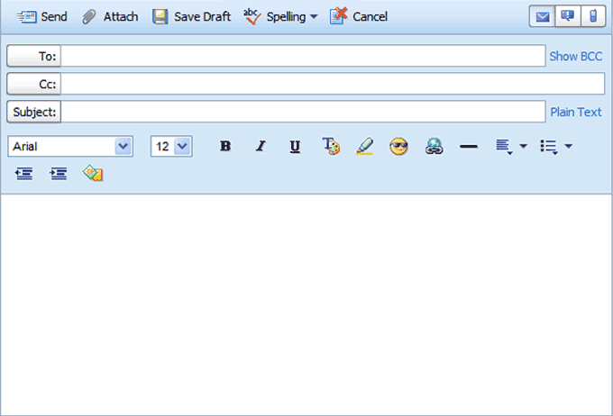

Job Search Email

Job Search Email Etiquette
By Alison Doyle, About.com Guide
When you are using email to job search, it's important that all your communications are as professional as they would be if you were writing an old-fashioned paper letter.
Here's information on all you need to know about job search email etiquette including what to include in your job search emails, how to format your email, and how to make sure your email message is read. In general, your email messages should include words, not acronyms or slang, full sentences, paragraphs, and detailed information on who you are and why you are sending the email. The email account you send your messages from, having a Subject Line completed, the files you attach, and your signature are important, as well.
Your Email Account Make sure you have an email account name that is appropriate for business use i.e. firstname.lastname@gmail.com. There are a variety of free web-based email accounts, like Gmail and Yahoo, that you can use. It also makes sense to set up an email account just for job searching, so your professional email doesn't get mixed in with your personal mail.
Where to Send Your Email Message When possible, send your email to a contact person, rather than a general email box. Send a copy to yourself, so you have a record of the emails you have sent and the jobs you have applied to.
Email Subject Line Your email message needs a Subject Line. If it's blank it's probably going to end up in a Spam mailbox or being deleted. Make sure you list the position you are applying for in the Subject Line of your email message, so the employer is clear as to what job you are applying for.
Email Subject Line Examples
- Subject Line: Communications Director Position
- Subject Line: Marketing Associate Position / Your Name
Email Message Content If you have a contact person, address your email to Dear Mr./Ms. LastName. If you don't, address your email to Dear Hiring Manager or simply start with the first paragraph of your message.
When you're applying for a job via email, copy and paste your cover letter into the email message or write your cover letter in the body of an email message. If the job posting asks you to send your resume as an attachment, send your resume as a PDF or a Word document.
When you're inquiring about available positions or networking, be clear about why you are writing and the purpose of your email message.
Include an Email Signature Include an email signature with your contact information, so it's easy for the hiring manager to get in touch with you. Including a link to your LinkedIn profile is a good way to give the hiring manager more information on your skills and abilities.
Sample Email Signature
FirstName LastName
Email Address
Phone
Cell Phone
LinkedIn Profile (Optional)
