Music and Transcendentalism Poster

Your assignment is to create a poster. This is the procedure for the assignment:

1. Select a quote from any music source. (Many song lyrics
are available on the internet.)

2. The quote should represent a viewpoint on conformity or nonconformity, free will, nonviolence, or other transcendental thought.

3. The poster will include:
a. the quote
b. the quote’s author (songwriter or performer)
c. a visual representation of the meaning of the quote

4. Be prepared to share your poster and have it displayed in the room to remind all
students of the differing perspectives that we have studied.

5. The poster should be approximately 14” x 22” (the size of a small poster board).

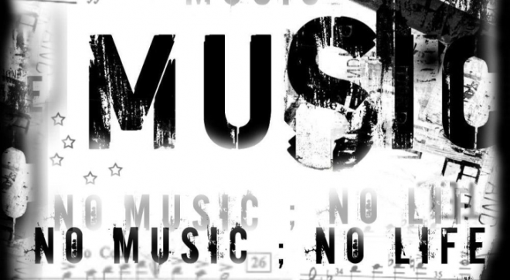

6. You may either create components on the computer or freehand, according to
your preference.

7. Your poster will be due in class on Friday, January 27.

8. This 75 point assignment will be graded on three things:

a. Quality and relevance of chosen quote – 35 points

b. Neatness – 15 points

c. How well you visually represented the quote’s meaning – 25 points

9. In case you are totally stumped, I have some resources listed on the back of this sheet; however, you will probably enjoy the assignment more if you search through your own collection of music.

10. Happy Listening!
Oldies/Classics
Otis Redding:
“Sitting on the Dock
of the Bay”
Louis Armstrong:
“What a Wonderful
World”
Billy Joel: “Just the
Way You Are”
Frank Sinatra:
“My Way”
Grateful Dead:
“Liberty”
Bob Marley: “Get
Up, Stand Up”
Beatles: “Here
Comes the Sun”
Bob Dylan: “Blowin’
in the Wind”
Joni Mitchell: “Big
Yellow Taxi”
Three Dog Night:
“Joy to the World”

Pop/Rock
Madonna: “Rain” and
“Respect Yourself ”
Mariah Carey: “Hero”
Dave Matthews Band:
“Cry Freedom”
U2: “Beautiful Day”
Van Halen: “Dreams”
Creed: “Higher”
Dido: “My Life”
Jewel: “Hands”
Backstreet Boys:
“Shining Star”
Bon Jovi: “My Life”
Vanessa Williams:
“Colors of the Wind”
Michael Jackson:
“Earth Song”
Whitney Houston:
“One Moment
in Time”
Sting: “Fields of Gold”

R&B/Rap
R. Kelly: “I Believe
I Can Fly”
Tupac Shakur:
“Keep Ya Head
Up”
Destiny’s Child:
“Survivor”
Desiree; “You
Gotta Be”
Jennifer Lopez:
“I’m Real”
Janet Jackson:
“Clouds”
India Arie: “Video”
Jermaine Jackson:
“Rise to the
Occasion”
En Vogue: “Free
Your Mind”

Country
Dixie Chicks: “Wide
Open Spaces”
Lee Ann Womack: “I
Hope You Dance”
Billy Gilman: “Hero”
Garth Brooks:
“The River” and “We
Shall Be Free”
Norman Blake: “You
Are My Sunshine”
Martina McBride:
“Independence Day”
Trisha Yearwood:
“Real Live Woman”
Tim McGraw: “Place
in the Sun”
Jo Dee Messina:
“Burn”
Rascal Flatts: “Prayin’
for Daylight”

