Identity Playing Card Instructions
As we are studying the Civil Rights movement, the main problem that divided our nation is judging by color and outside appearance alone, rather than the heart. For this assignment, you are going to create a deck of 9 playing cards. On those cards, you will make a symbol and write words representing WHO YOU REALLY ARE on the inside (See example).
For the playing card box, you will decorate it with your NAME, and all the ways you might be seen on the OUTSIDE. How do others who don’t know you see you? What does your OUTSIDE appearance say about you?
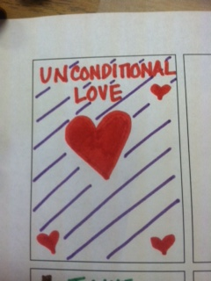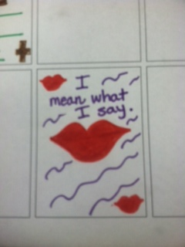
Sample Playing Card.
The symbol is a heart, and the words are UNNCONDITIONAL LOVE - something I have on the inside that you wouldn’t know unless you got to know me.
The playing card box template can be found at Milkwood Designs:
http://www.ruthannzaroff.com/mirkwooddesigns/templates.htm
The playing cards template can be found:
http://www.wired.com/geekdad/2008/07/help-your-kids/

Brainstorming:
How do others see you before they know you?
__________________________________________________
__________________________________________________
What qualities do you wish they could REALLY see on the inside?
__________________________________________________
__________________________________________________
Now, transfer those ideas with symbols to represent them to your box & cards.

