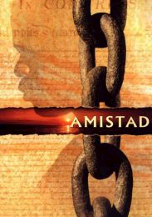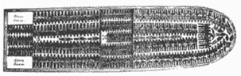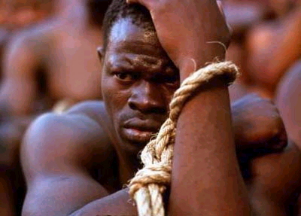

While watching, write down in the box below some of the things you can see happening in the film clip

*I can see the following things happening.....*

|  |  |
| --- | --- |
| **Senses** | **Describe what life was like for slaves crossing the Middle passage** |
| **See** |  |
| **Hear** |  |
| **Smell** |  |
| **Touch/ feel** |  |