Declaration of Independence

NOTE SHEET

Name: ____________________________________________ Period: ____________

**Bellwork**: Today is the 2nd day of the 12 days of gratitude. In your journal, write a 5-7 sentence entry about something for which you are thankful. Then answer the question below.

Answer this: When is rebellion justified? When is okay to rebel? ____________________________________________________________________________

**In June 1776, colonial leaders decided to rebel against British rule. But they needed to justify their dangerous action – to themselves, to the king and to the WORLD.**

At your table: think of several situations in which an individual or a group rebelled against a perceived injustice (write them below):

C:\Users\clwisehart\AppData\Local\Microsoft\Windows\Temporary Internet Files\Content.IE5\3ZF4Q1Y3\MC900389272[1].wmf

**SO HOW DID THE COLONIAL LEADERS JUSTIFY THEIR ACTIONS?!?**

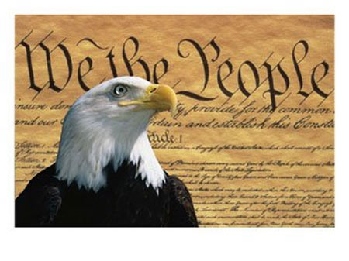

Write it here:___________________________________________________________________

BACKGROUND:

In __________________________, 56 delegates met in ______________________ to draw up a declaration of colonial rights. The task of writing it fell to _______________________________. Although Congress made many changes to the list of _________________, Jefferson’s declaration of rights remained untouched – an abiding testament to _________________ truths for the nation and the world.

**ON EACH TABLE (there are 2 words on 3 tables) is a word (or words) that will be found in the Declaration of Independence. You may use your phones and your neighbors to look up what word matches to each definition below:**

C:\Users\clwisehart\AppData\Local\Microsoft\Windows\Temporary Internet Files\Content.IE5\3ZF4Q1Y3\MC900389272[2].wmf

DEFINITION WORD

Correction

Integrity

Treachery

Abandon

Drive

Erratic

A taking over

Hired soldier

Tyranny

Unchangeable

4 parts of the Declaration of Independence

1. __________________ that announces the reason for the document.
2. __________________ of people’s natural rights & relationship to government
3. A long list of ________________________ against George III, the British King
4. A ___________________ that formally states America’s independence.

Read this short passage from the Declaration.

We hold these truths to be self-evident: - That all men are created equal; that they are endowed by their Creator with certain unalienable rights; that among these are life, liberty, and the pursuit of happiness. That, to secure these rights, governments are instituted among men, deriving their just powers from the consent of the governed; that, whenever any form of government becomes destructive of these ends, it is the right of the people to alter or to abolish it, and to institute a new government, laying its foundation on such principals, and organizing its powers in such form, as to them shall seem most likely to effect their safety and happiness.

According to what you just read, what rights do people have that cannot be taken away? Underline them in the passage.

According to the passage, when do people have the right to form a new government?

________________________________________________________________________________________________________________________________________________________________________________________________________________________

Grievances

Your table will be given a list of grievances the colonists had with Britain and the King.

C:\Users\clwisehart\AppData\Local\Microsoft\Windows\Temporary Internet Files\Content.IE5\3ZF4Q1Y3\MC900389272[2].wmf

**Directions:**

1. Read the complaints assigned to your group.

2. Discuss each complaint with your group.

3. Answer these questions:

Questions:

1. What is each complaint about? Write a brief description of each complaint in your own words.

2. Who is “He” that the colonists refer to in the grievances?

3. Who are the colonists blaming for their grievances? Why do you think they are blaming him?